--1

select c.customer_id,c.cust_first_name, c.cust_last_name, SUM(o.order_total)

from DEMO_CUSTOMERS c

join DEMO_ORDERS o on c.customer_id = o.customer_id

group by c.customer_id, c.cust_last_name, c.cust_first_name

order by 4 desc

fetch first 3 rows only;

--2

select c.customer_id, c.cust_first_name, c.cust_last_name, count(o.order_id)

from DEMO_CUSTOMERS c

join DEMO_ORDERS o on c.customer_id = o.customer_id

group by c.customer_id, c.cust_last_name,c.cust_first_name

order by 4 desc

fetch first 3 rows only;

--3

select p.product_id, p.product_name, SUM(oi.quantity)

from DEMO_PRODUCTS p

join DEMO_ORDER_ITEMS oi on p.product_id = oi.product_id

group by p.product_id, p.product_name

order by 3 desc

fetch first 3 rows only;

--4

select c.cust_last_name, p.product_name, SUM(oi.quantity)

from DEMO_CUSTOMERS c

join DEMO_ORDERS o on c.customer_id = o.customer_id

join DEMO_ORDER_ITEMS oi on o.order_id = oi.order_id

join DEMO_PRODUCTS p on oi.product_id = p.product_id

group by c.cust_last_name, p.product_name;

--5

select cust_last_name,

max(case when product_name = 'Product1' then total_quantity else 0 end) as Product1,

max(case when product_name = 'Product2' then total_quantity else 0 end) as Product2,

max(case when product_name = 'Product3' then total_quantity else 0 end) as Product3

from (

select c.cust_last_name, p.product_name, sum(oi.quantity) as total_quantity

from DEMO_CUSTOMERS c

join DEMO_ORDERS o on c.customer_id = o.customer_id

join DEMO_ORDER_ITEMS oi on o.order_id = oi.order_id

join DEMO_PRODUCTS p on oi.product_id = p.product_id

group by c.cust_last_name, p.product_name

)

group by cust_last_name;

--6

select EXTRACT(year from o.order_timestamp) as order_year, count(o.order_id) as order_count

from DEMO_ORDERS o

group by EXTRACT(year from o.order_timestamp)

order by order_count desc

fetch first 1 rows only;

--7

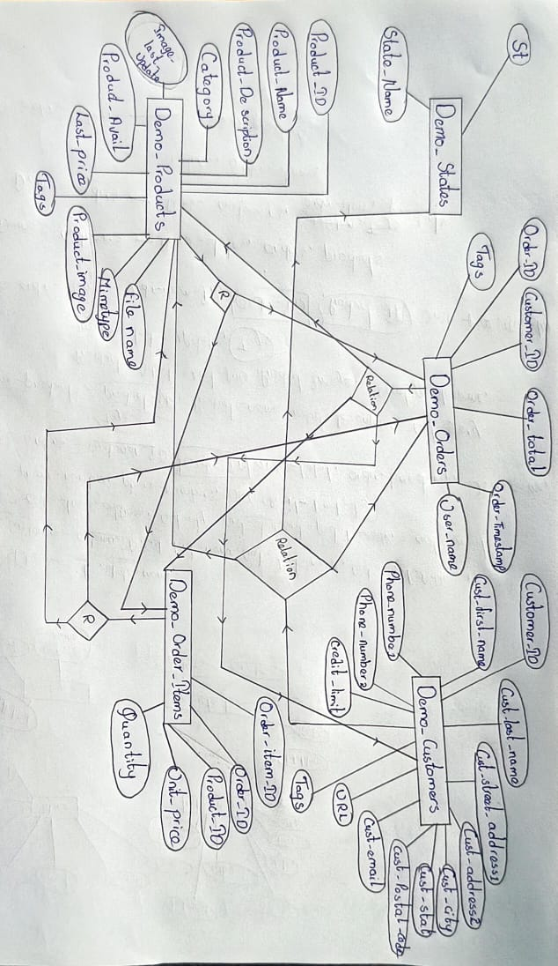

--8

select p.category, SUM(oi.quantity) as total_quantity

from DEMO_PRODUCTS p

join DEMO_ORDER_ITEMS oi on p.product_id = oi.product_id

group by p.category

order by total_quantity desc

fetch first 1 rows only;

--9

select p.category, SUM(oi.quantity) as total_quantity

from DEMO_PRODUCTS p

join DEMO_ORDER_ITEMS oi on p.product_id = oi.product_id

group by p.category

order by total_quantity desc

offset 1 rows fetch first 1 row only;

--10

select c.cust_last_name, p.product_name, SUM(oi.quantity) as total_quantity

from DEMO_CUSTOMERS c

join DEMO_ORDERS o on c.customer_id = o.customer_id

join DEMO_ORDER_ITEMS oi on o.order_id = oi.order_id

join DEMO_PRODUCTS p on oi.product_id = p.product_id

group by rollup (c.cust_last_name, p.product_name);